|  |  |
| --- | --- |
| **DOKUMENTASI EKSTERNAL**  ***External Documentation*** |  |
| **PROYEK**  ***Project*** |
| **COMP6176 - Human and Computer Interaction**  ***Subject*** |
| **SEMESTER [GENAP] 2020/2021**  ***[ Even Semester Year 2020/2021*** |

## **Judul Proyek**

**YBIKE**

## **Pendahuluan**

*Introduction*

**·** YBIKE is a motorcycle dealer formed on December 30, 2016 and based in Jakarta, Indonesia. YBIKE sells motorcycles from 2 famous brands of motorcycle: Vixian and Kawasako. The dealer is led by Carvin Joestar. The products are kept inside a secure warehouse and covered with a large fabric to keep them clean of dusts. And now,

## **Dokumentasi**

* **Home Page**

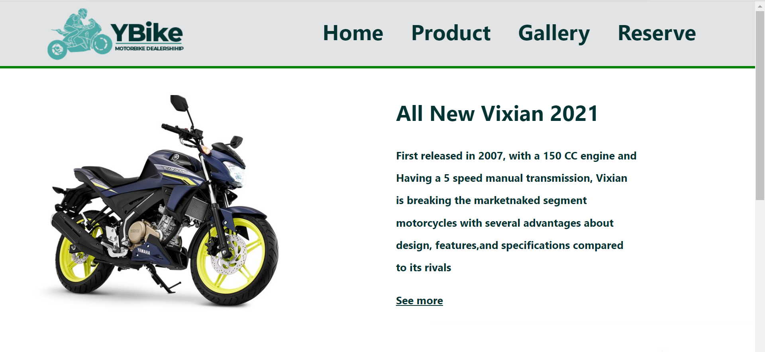

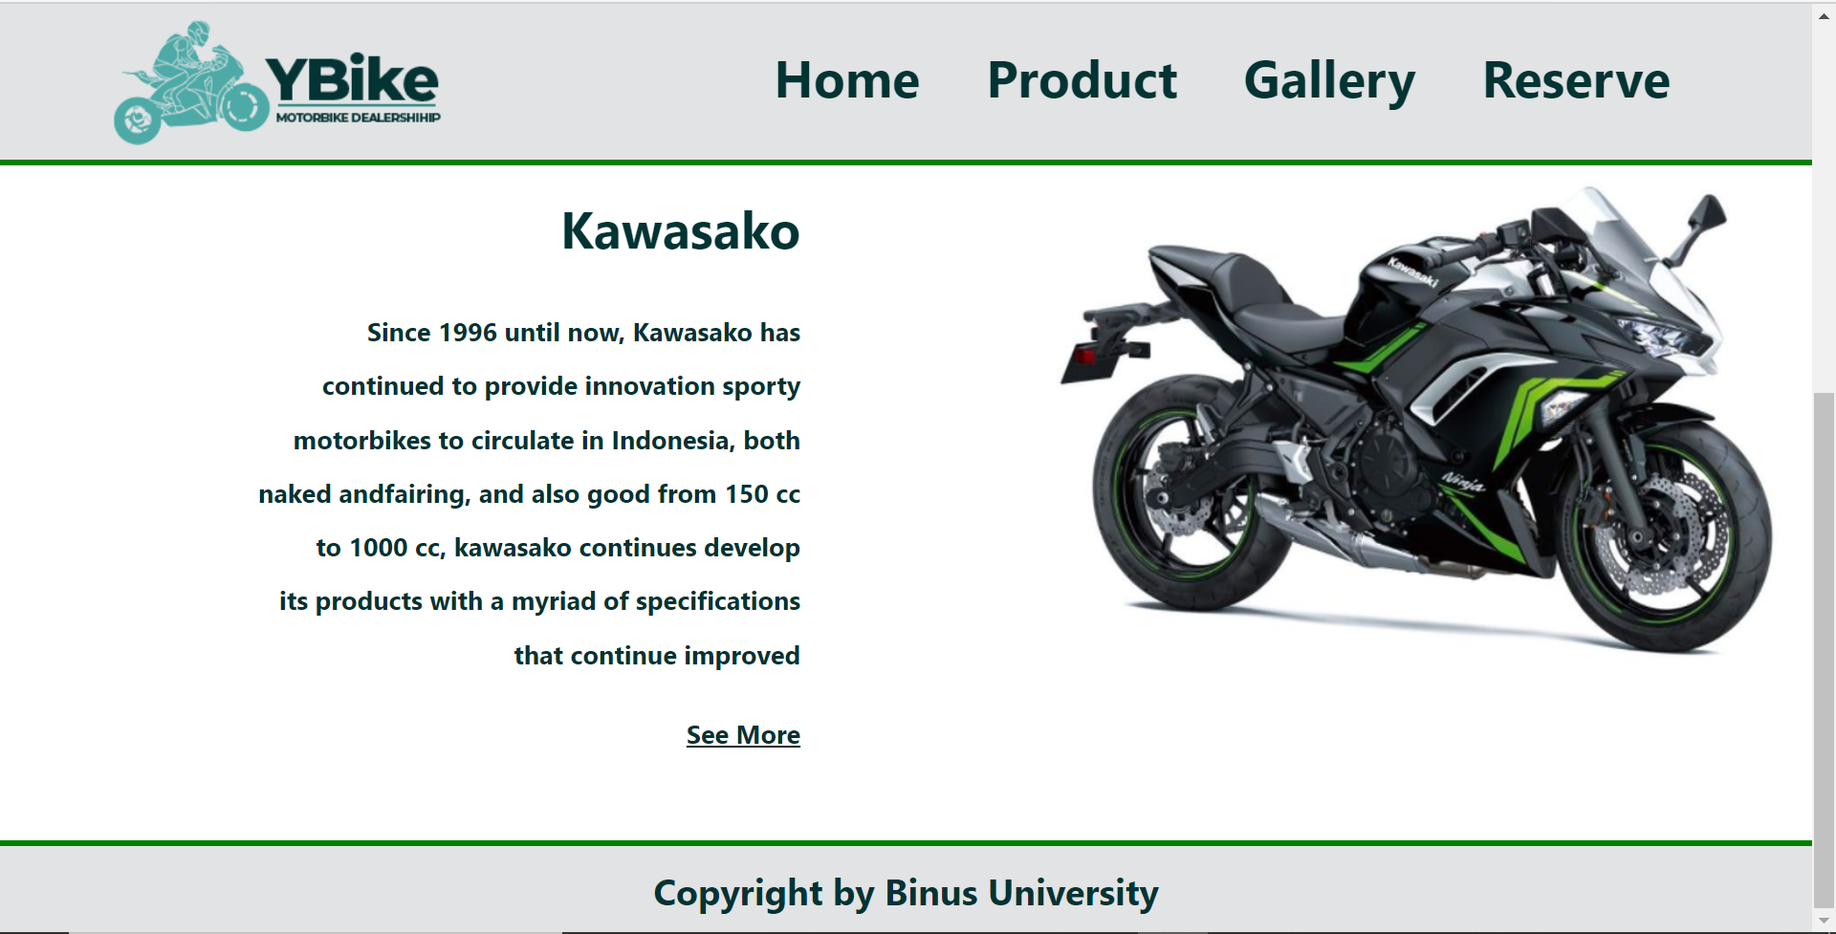

**(Dropdown pada menu Product)**

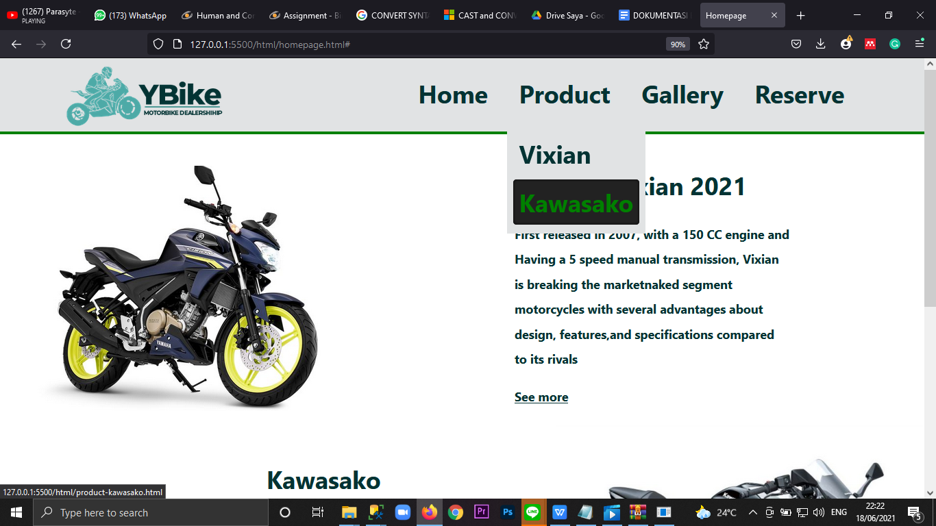

* **Tampilan Responsif pada Home Page:**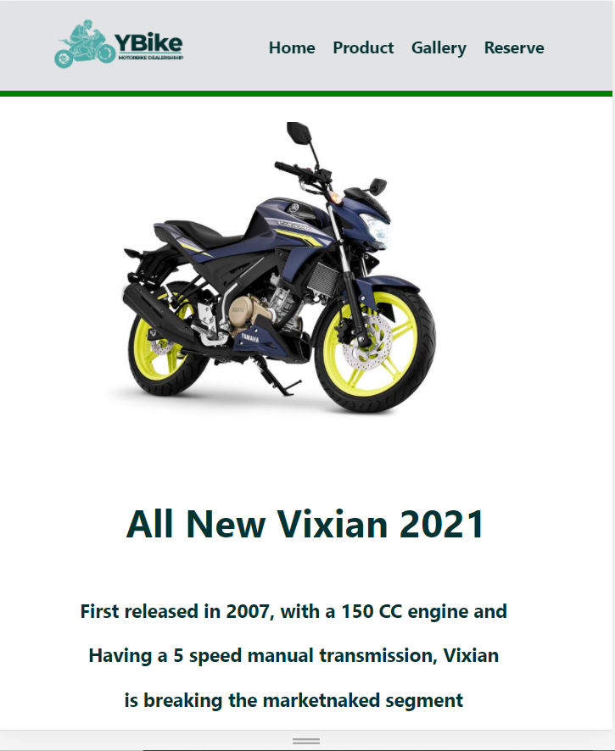

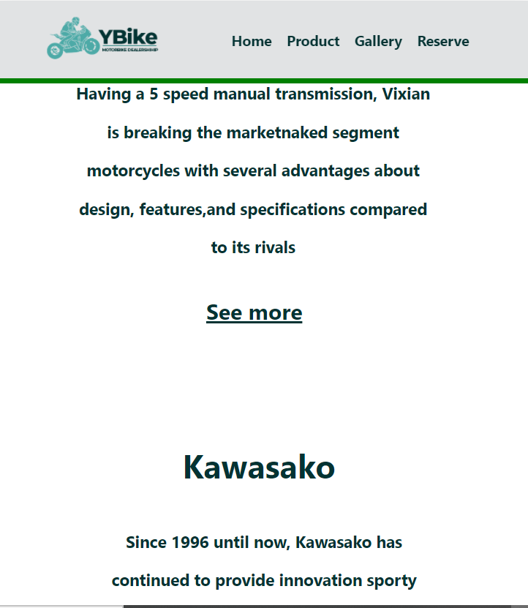

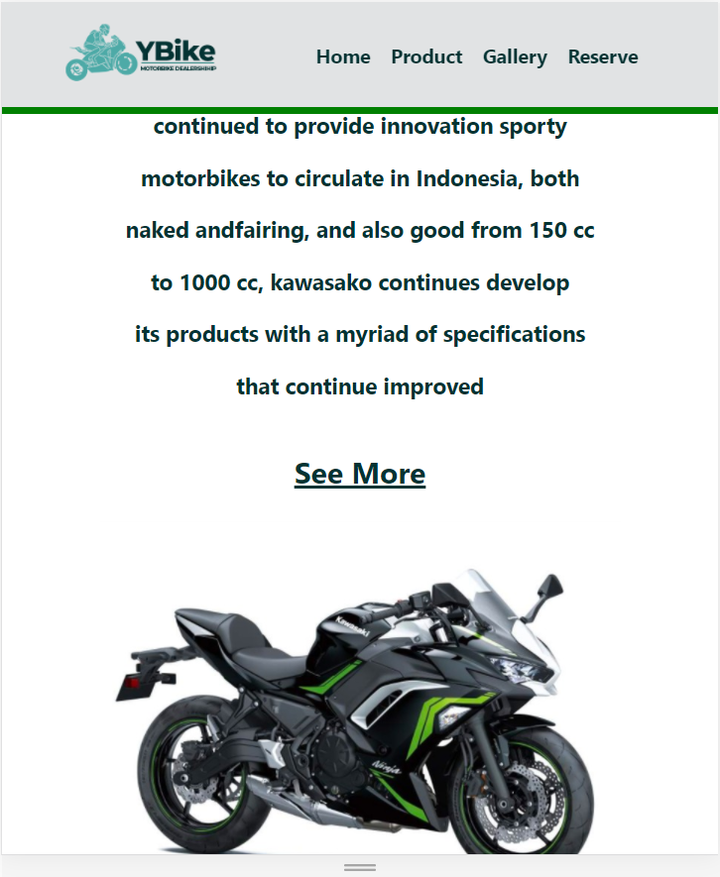

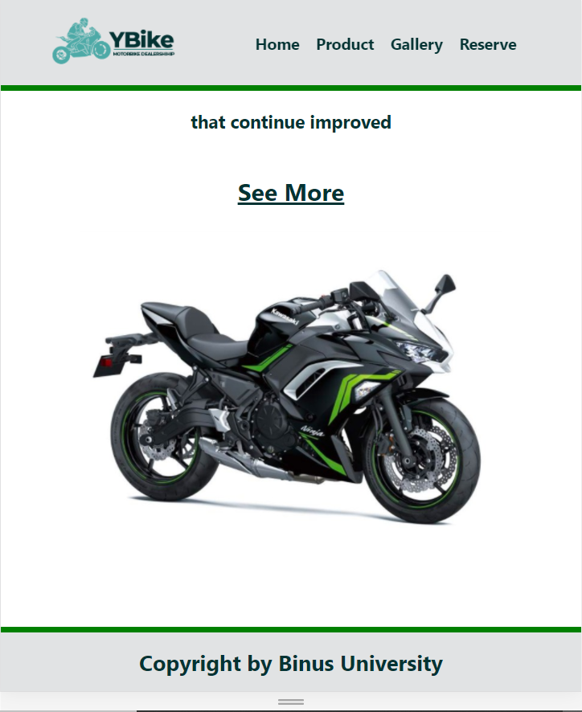

* **Home**

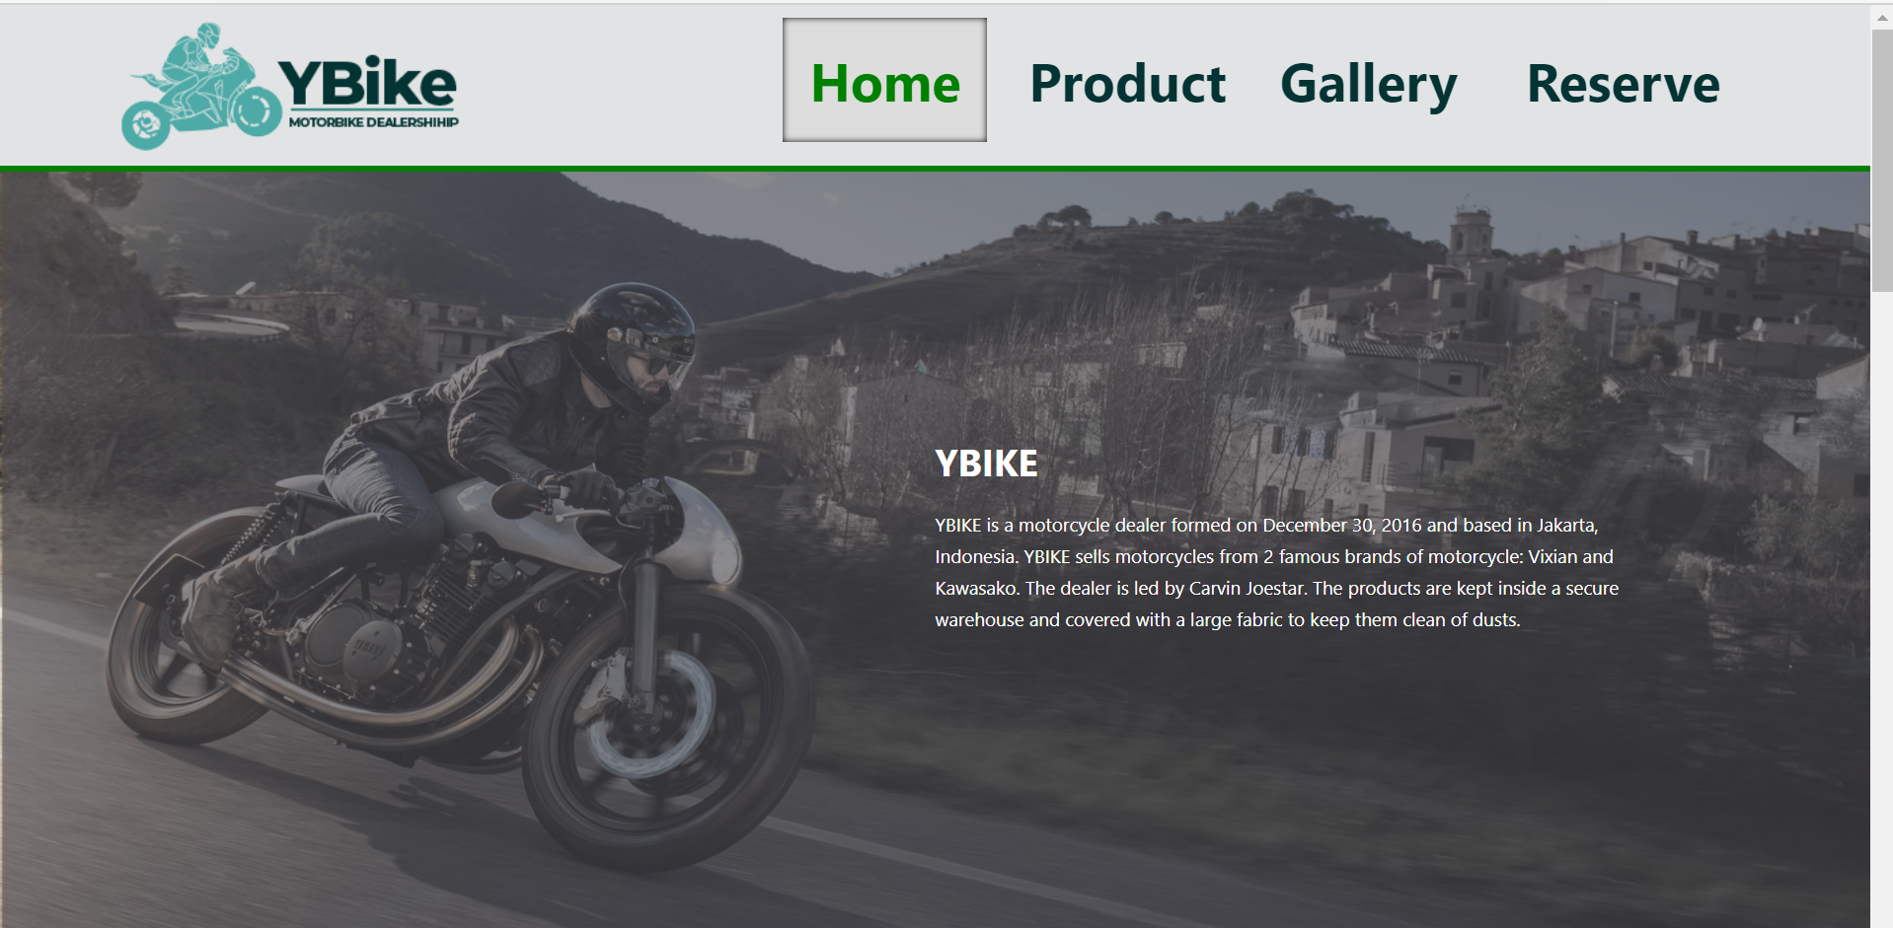

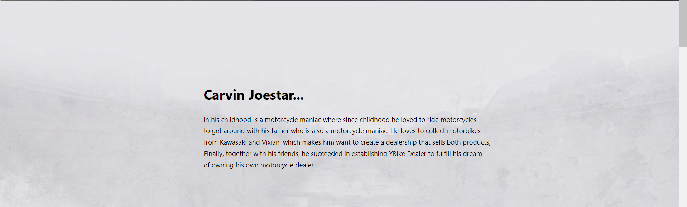

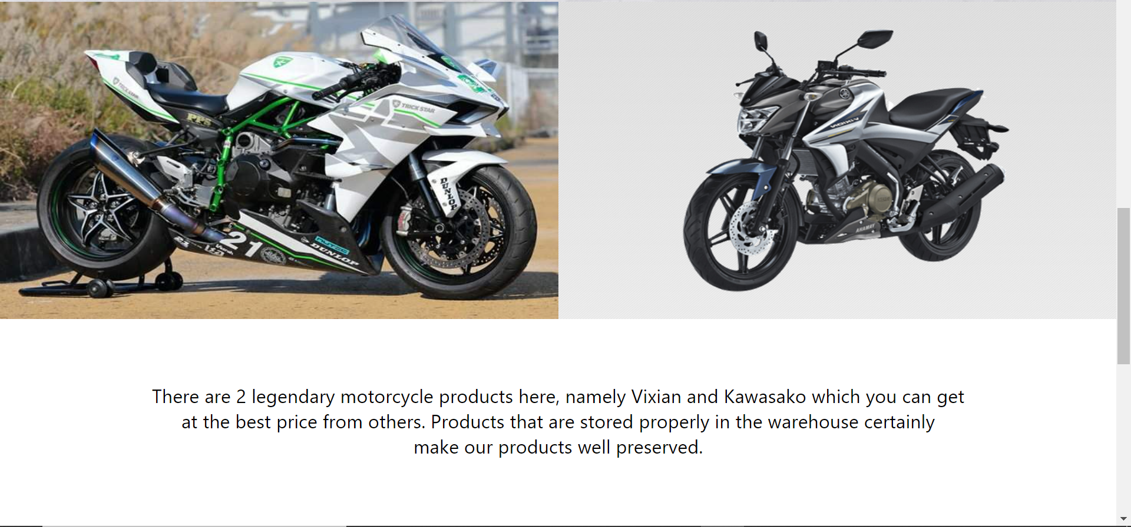

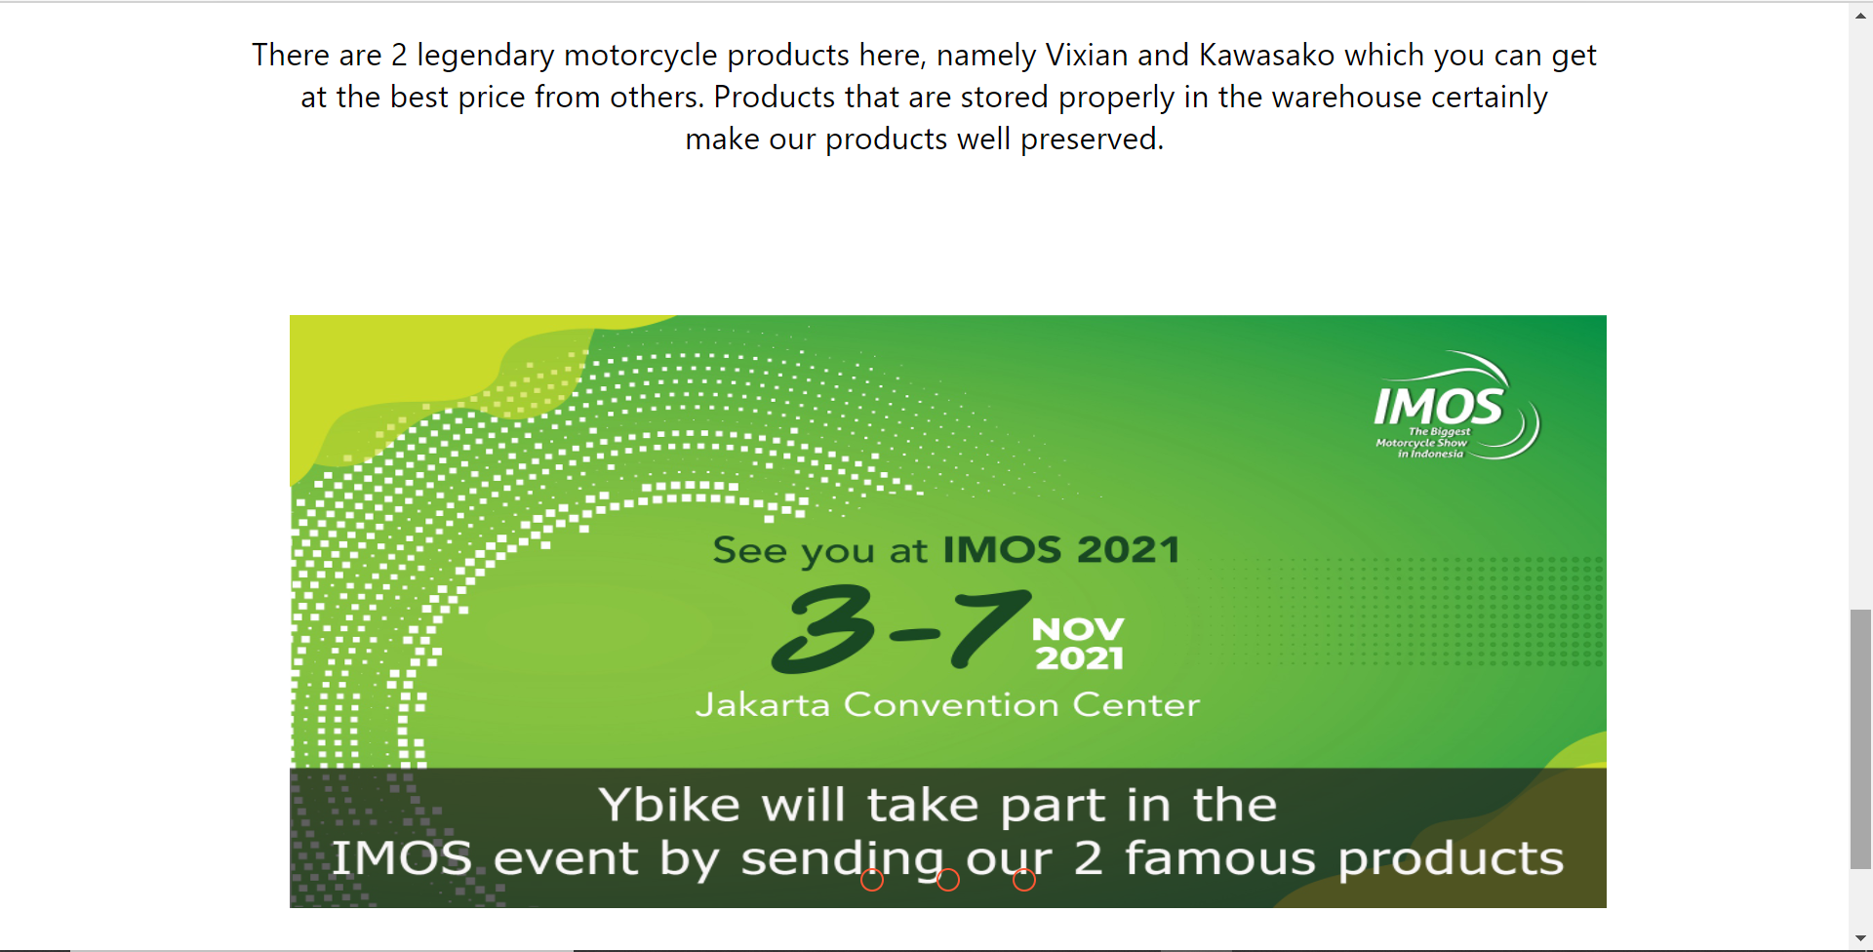

* **Tampilan responsif pada halaman home**

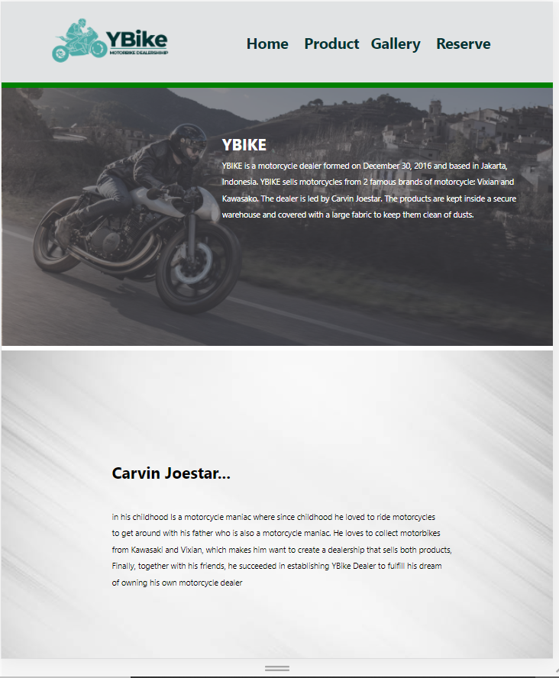

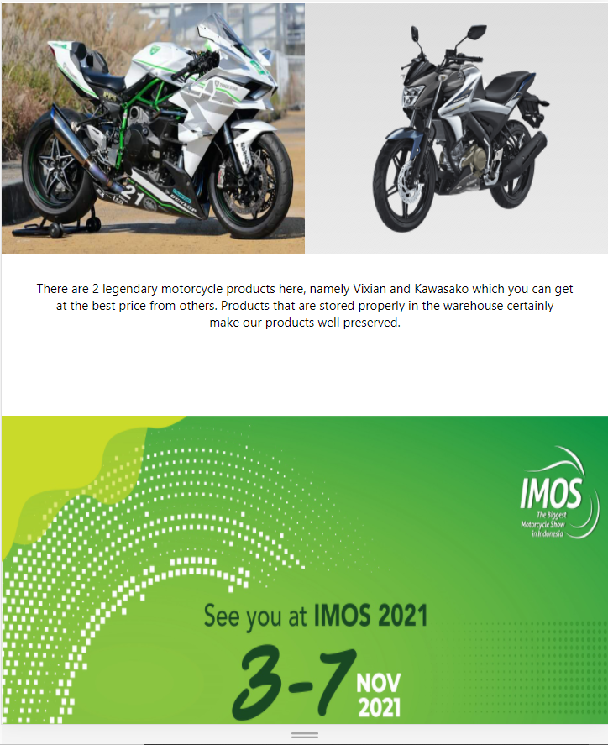

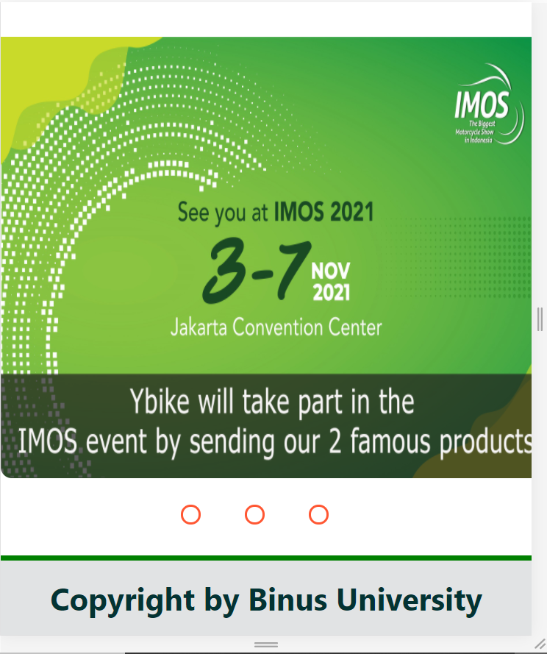

* **Product vixian**

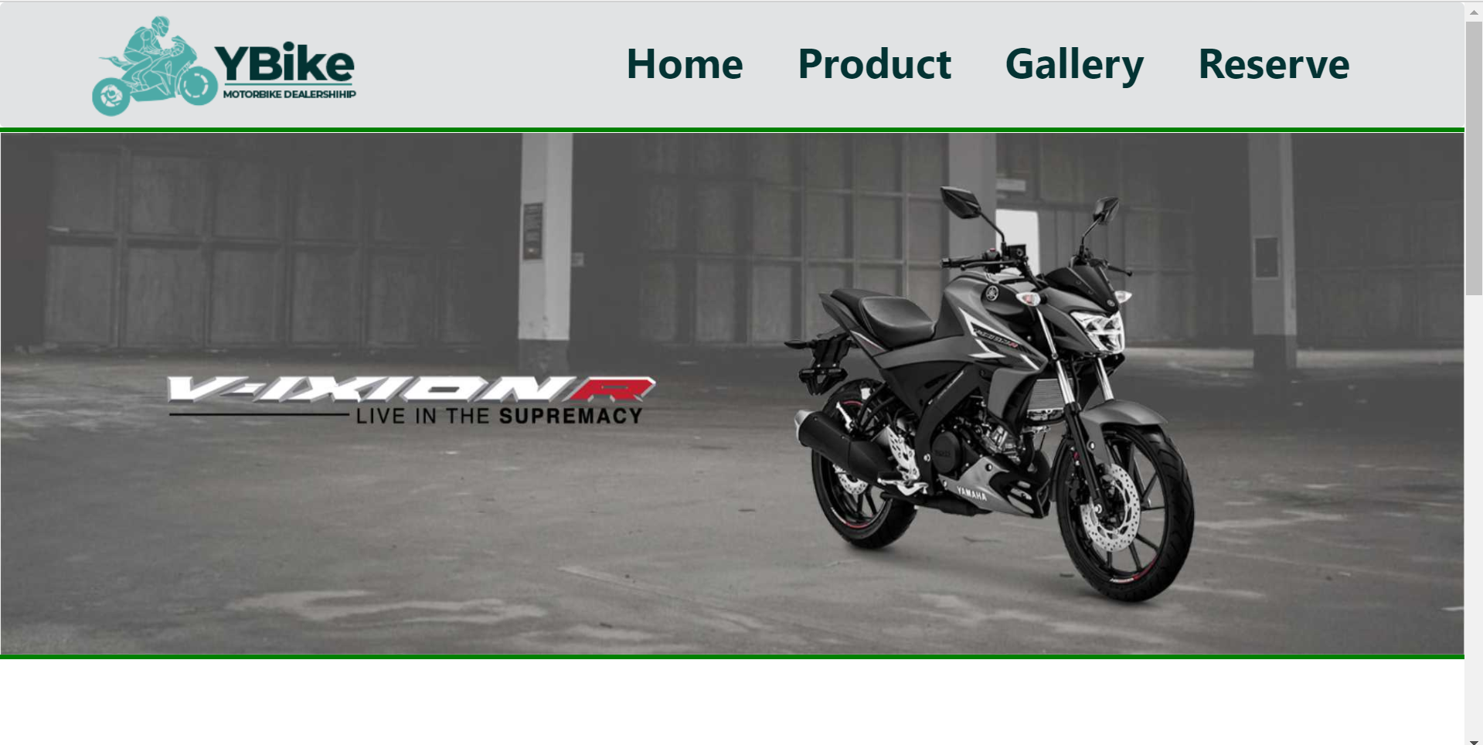

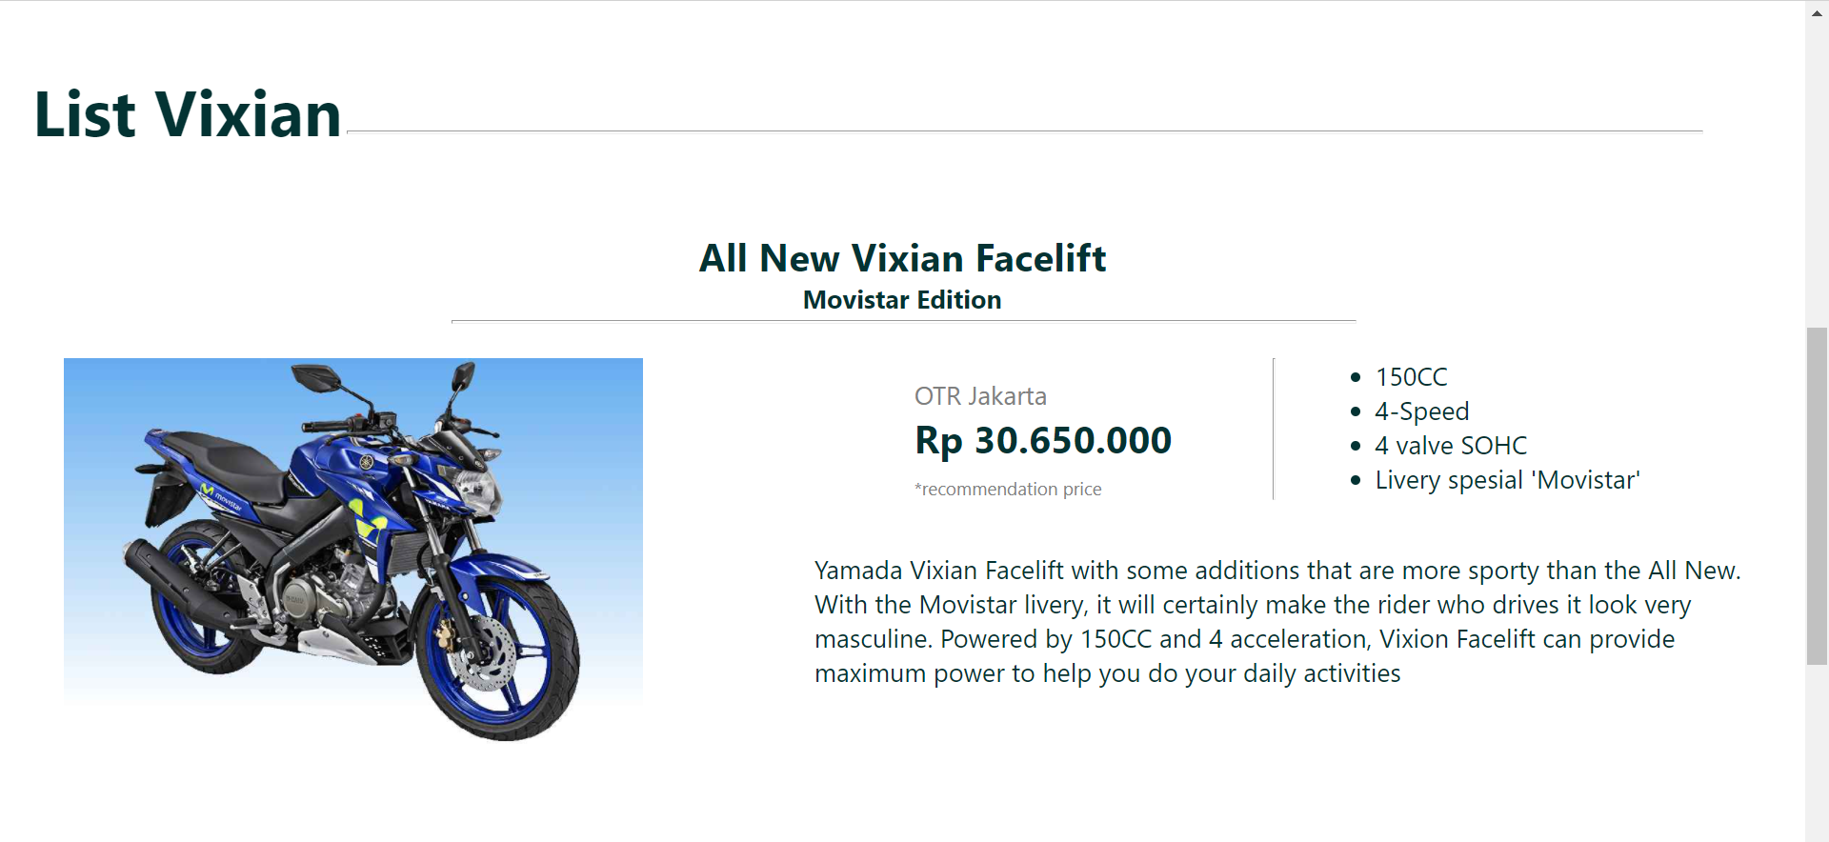

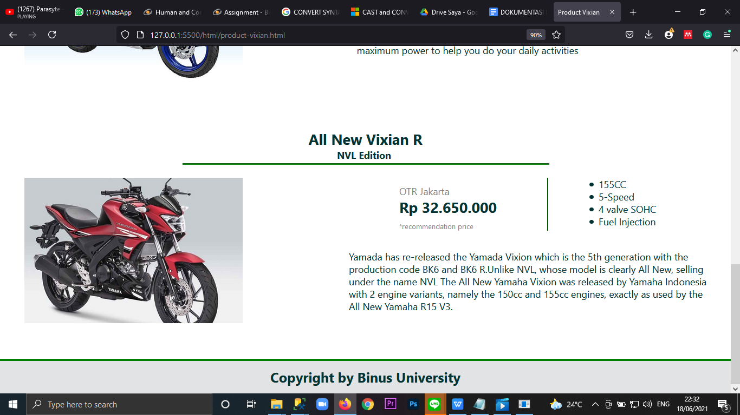

* **Tampilan responsif pada halaman Product vixian**

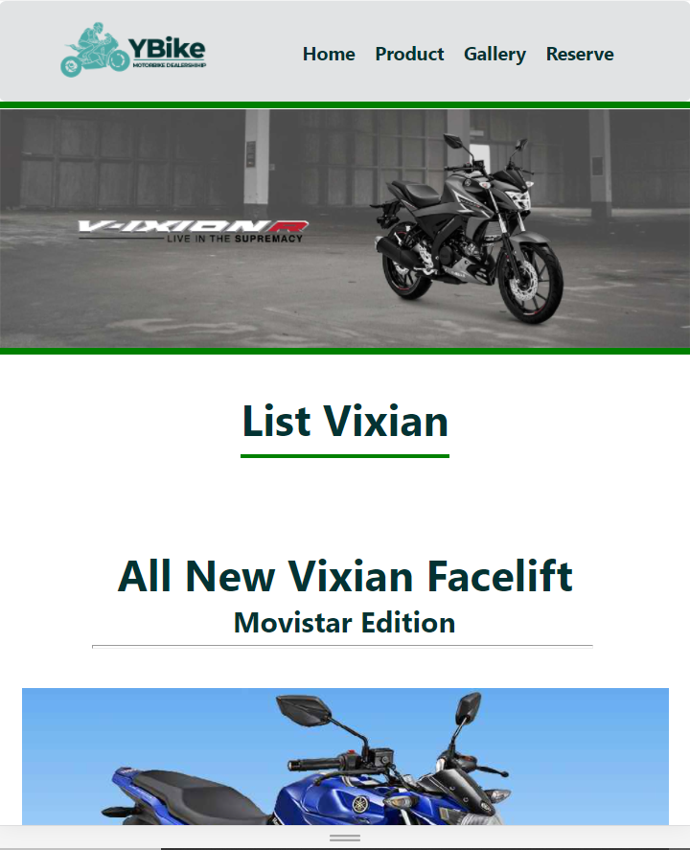

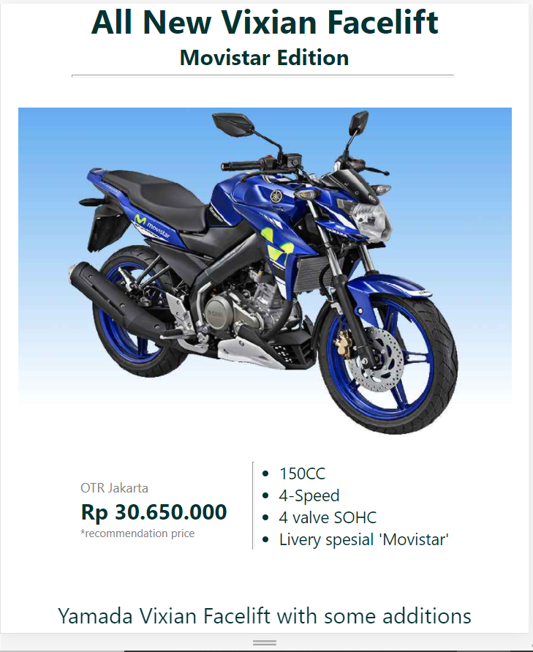

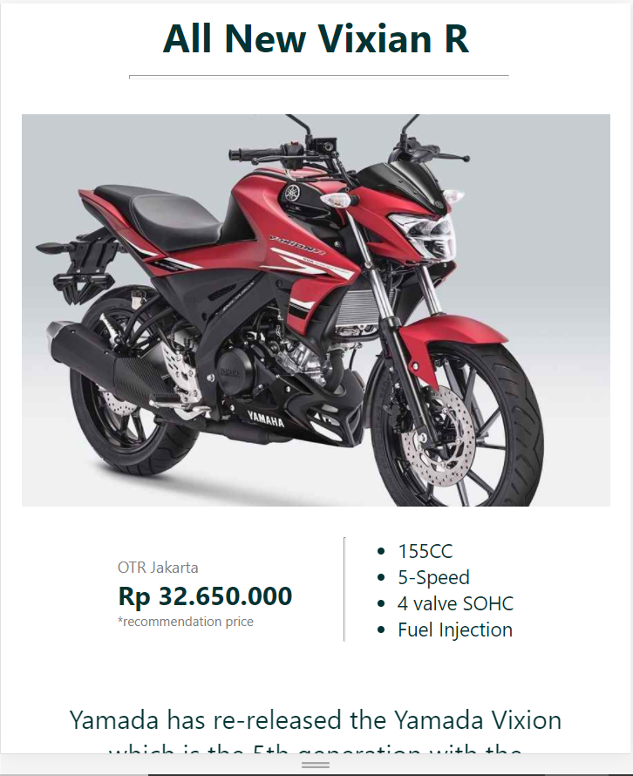

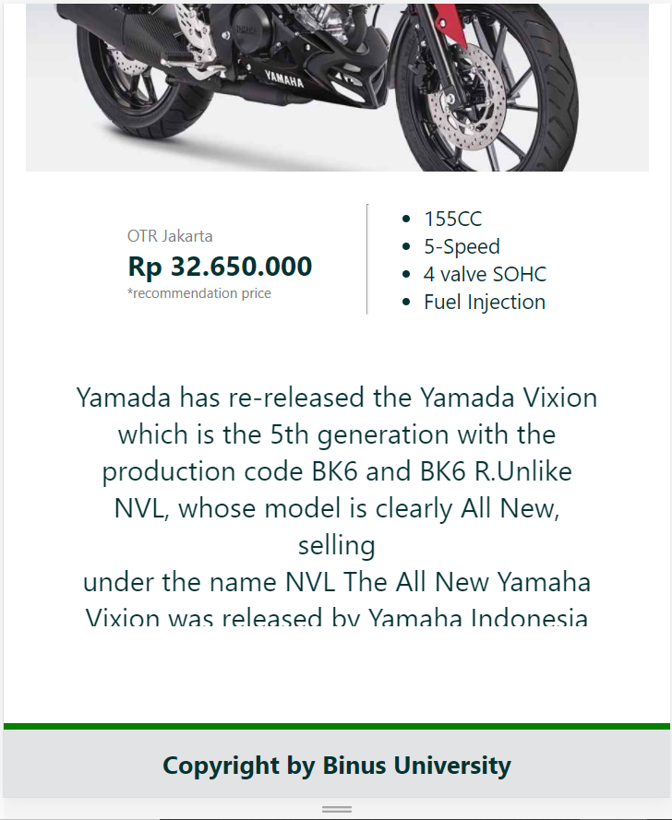

* **Product Kawasako**

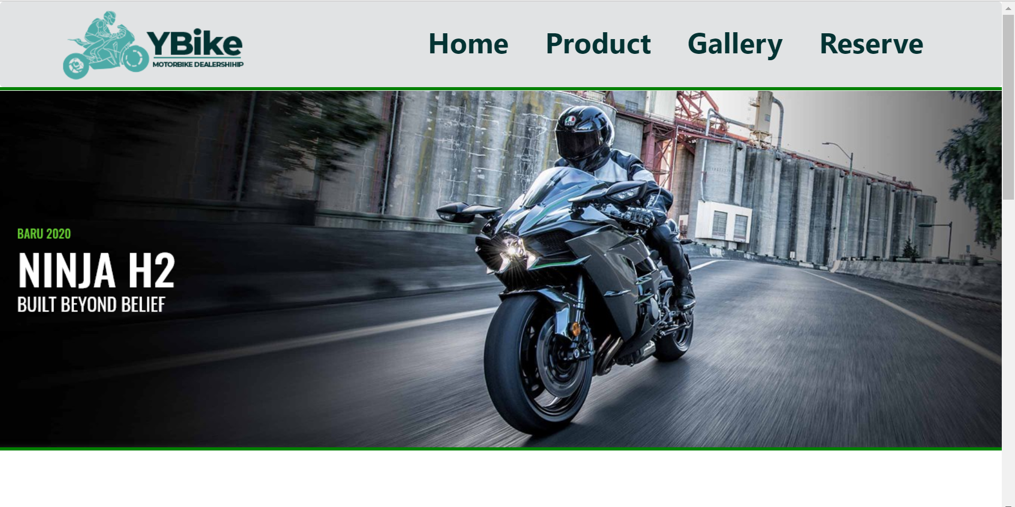

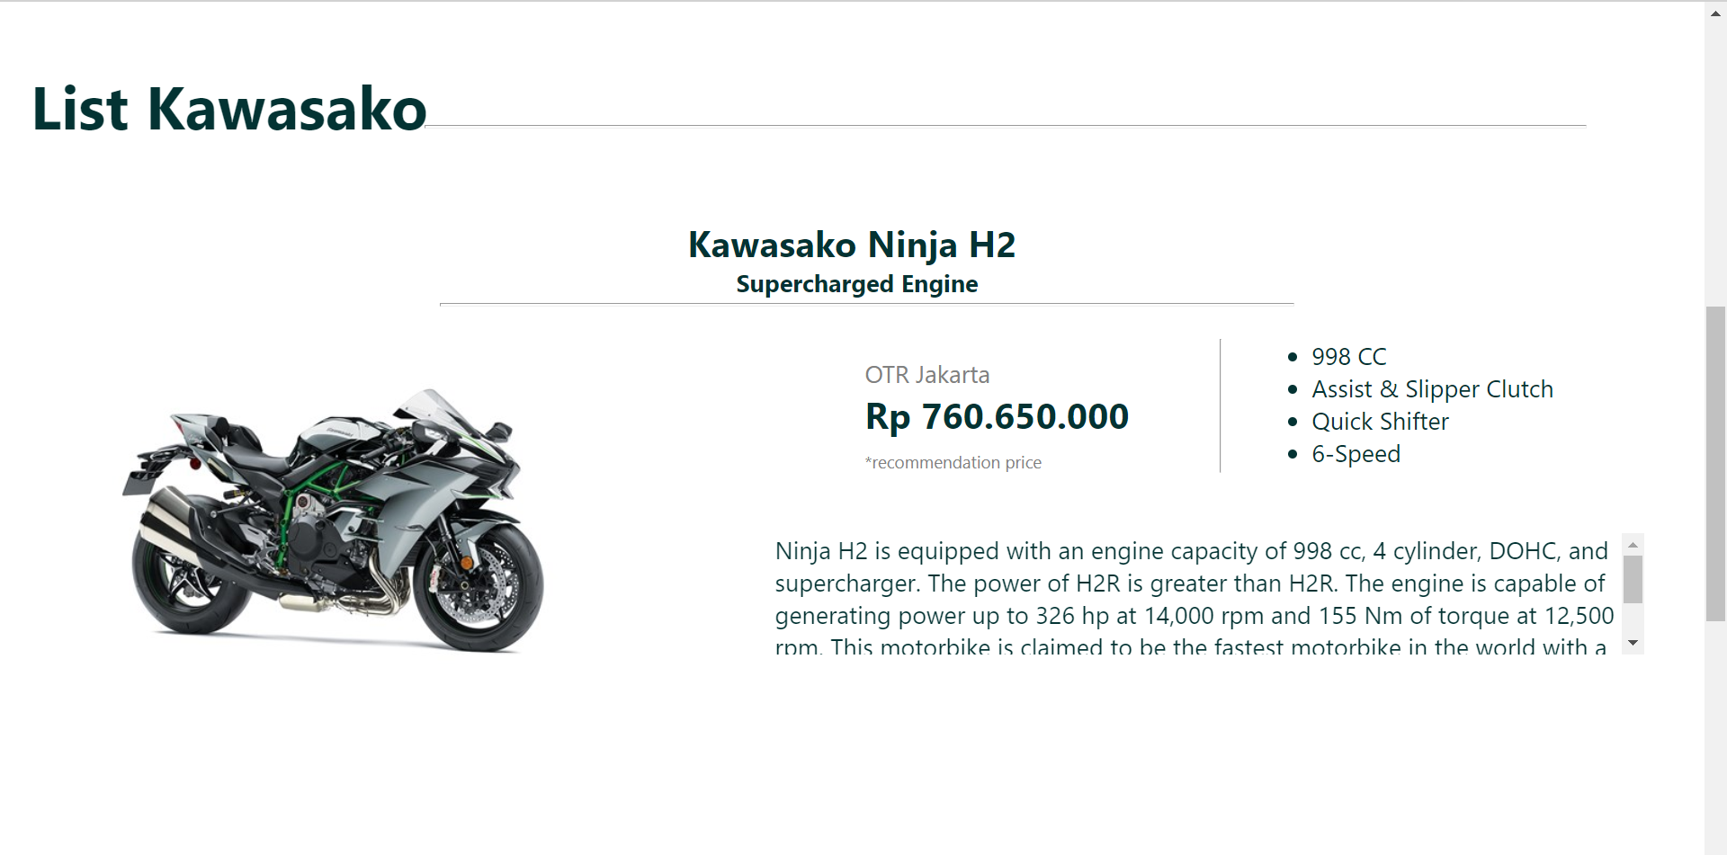

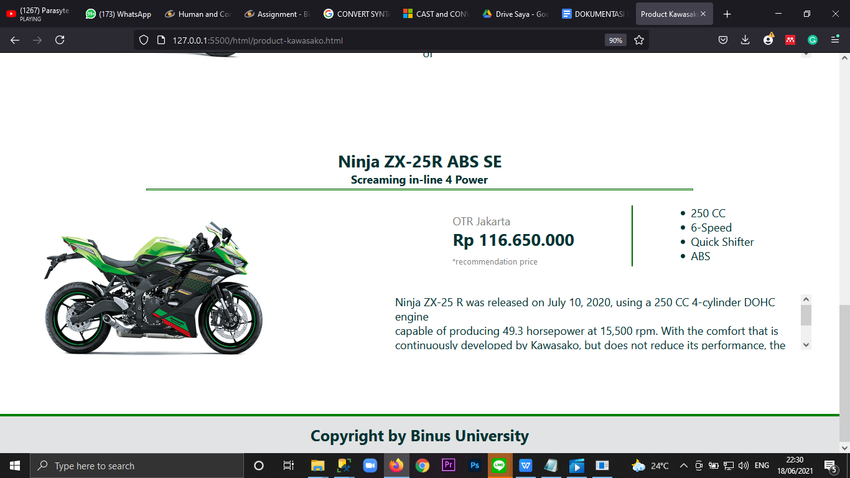

* **Tampilan responsif pada halaman product kawasako**

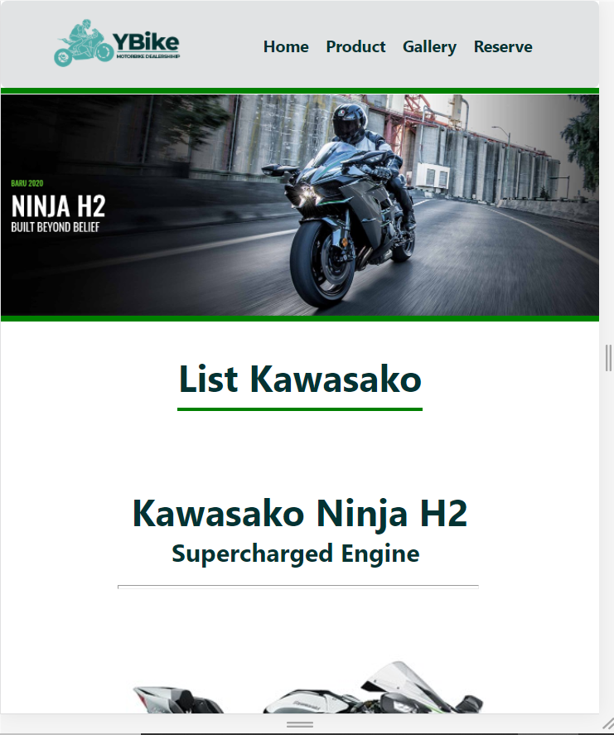

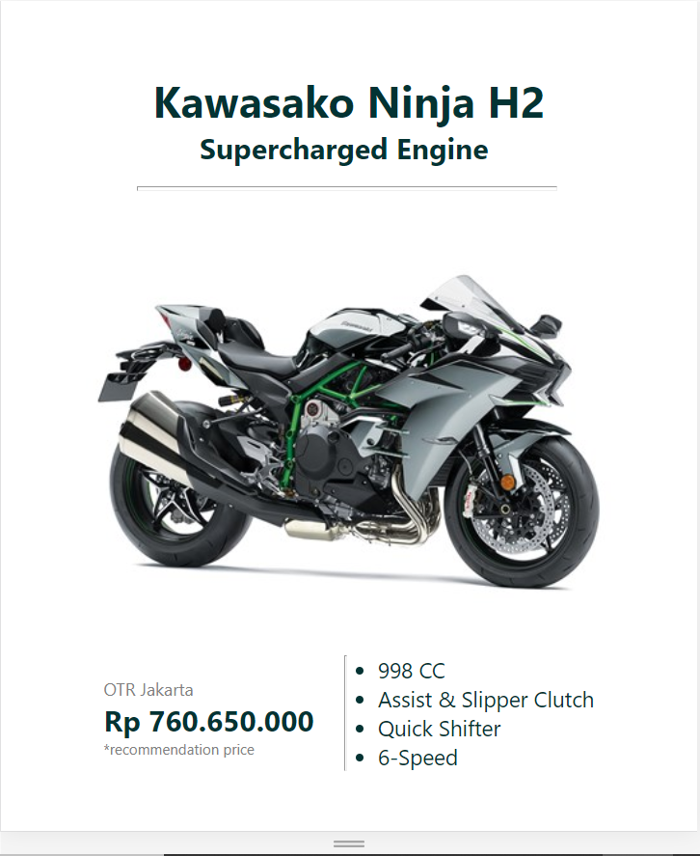

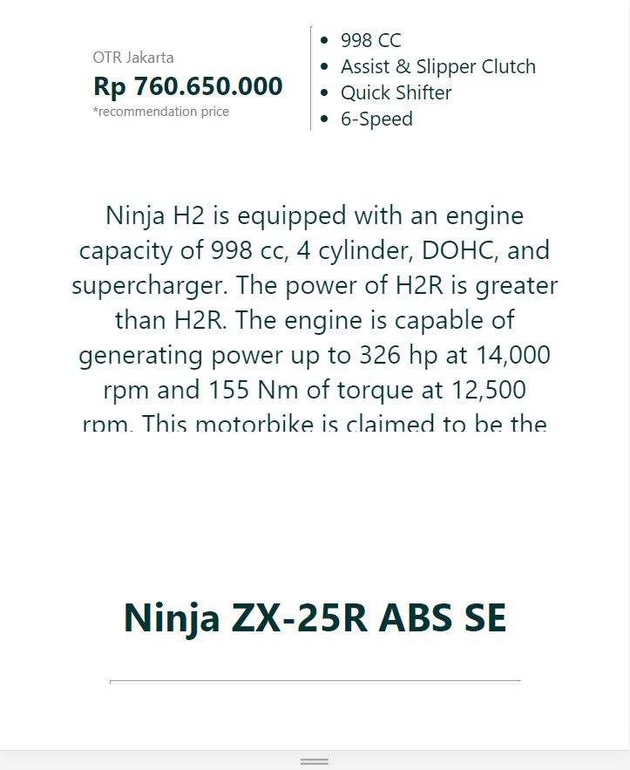

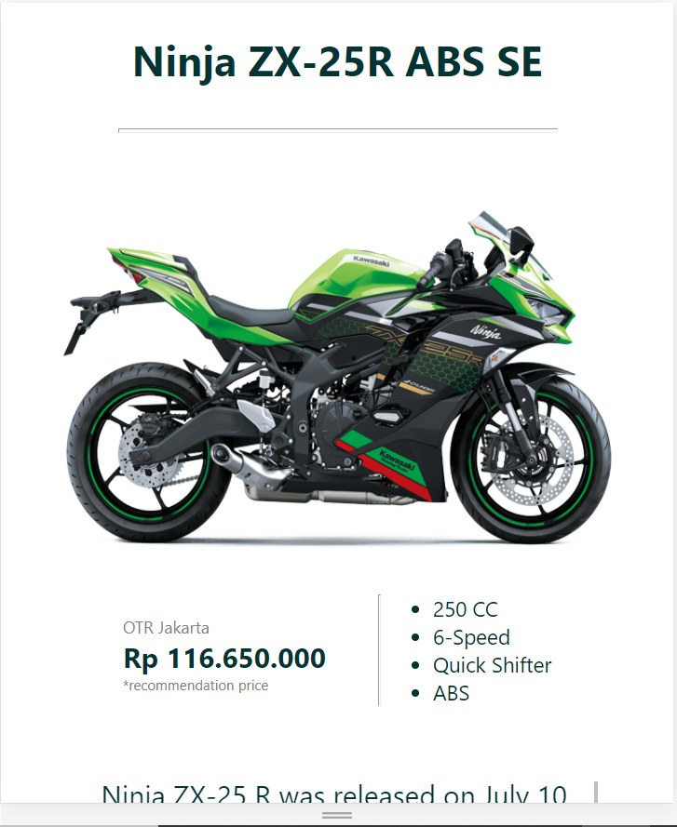

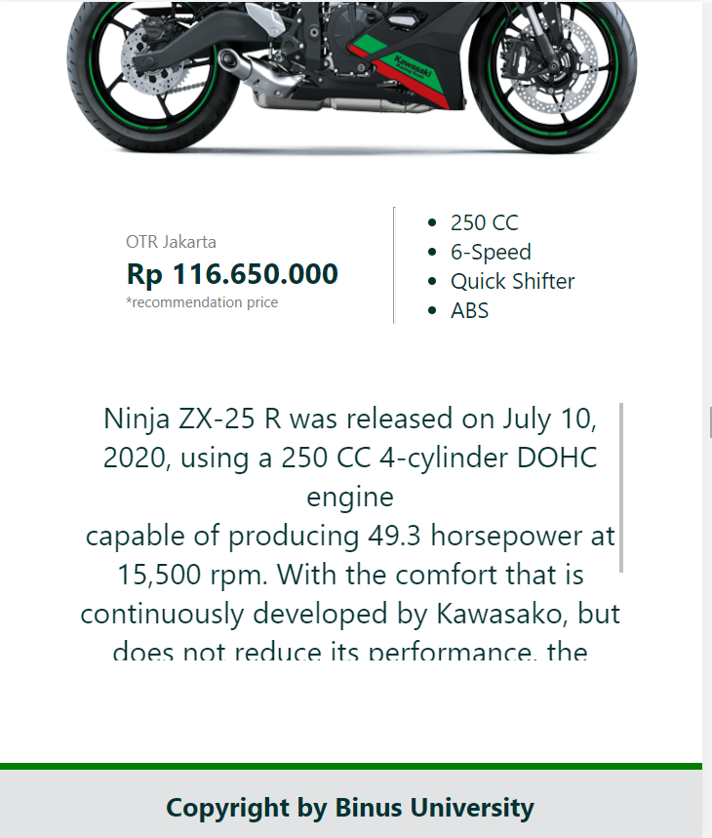

* **Gallery**

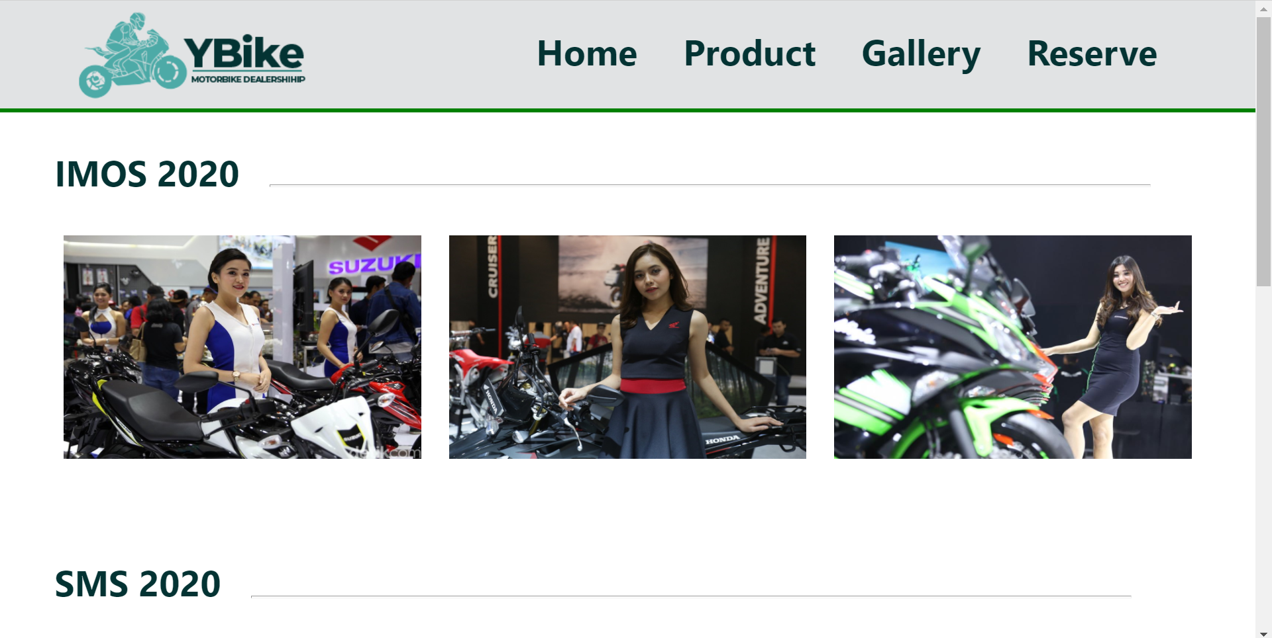

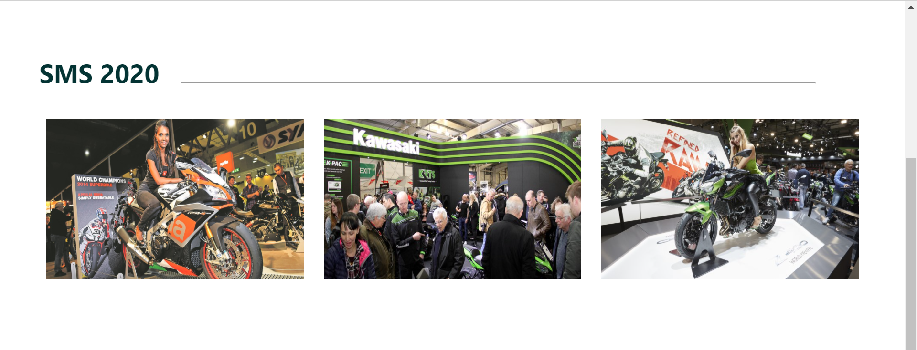

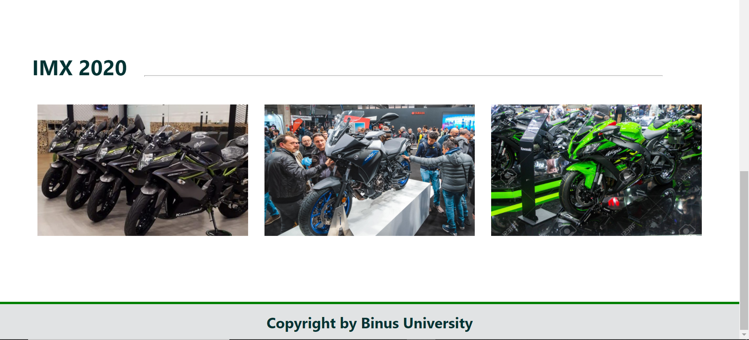

* **Tampilan responsif pada halaman Gallery**

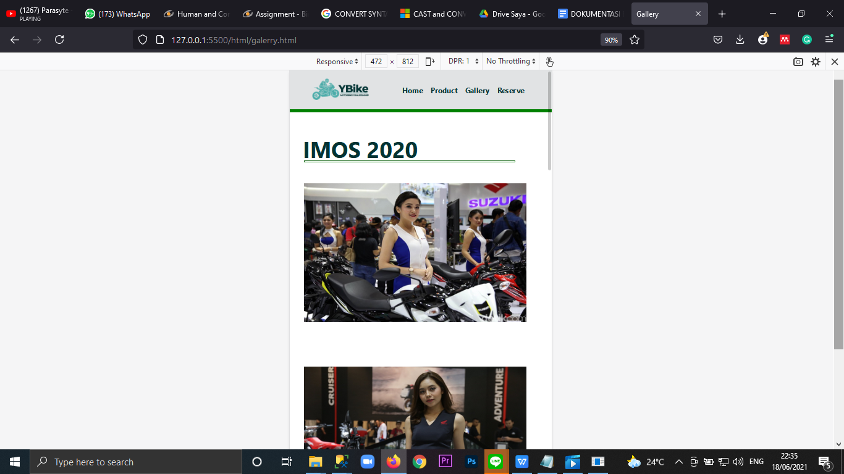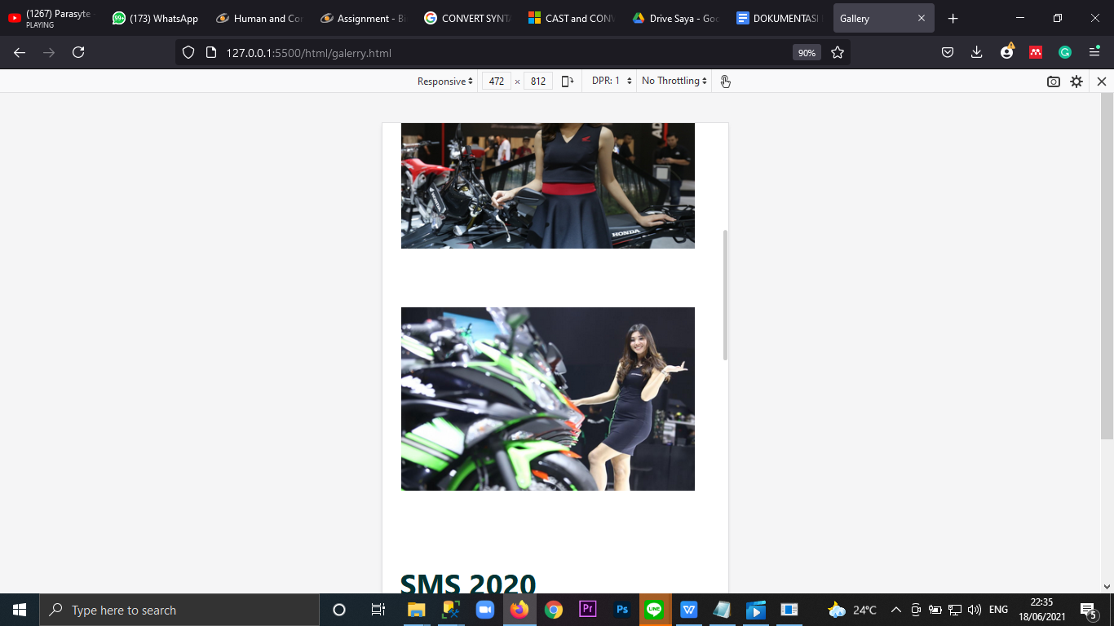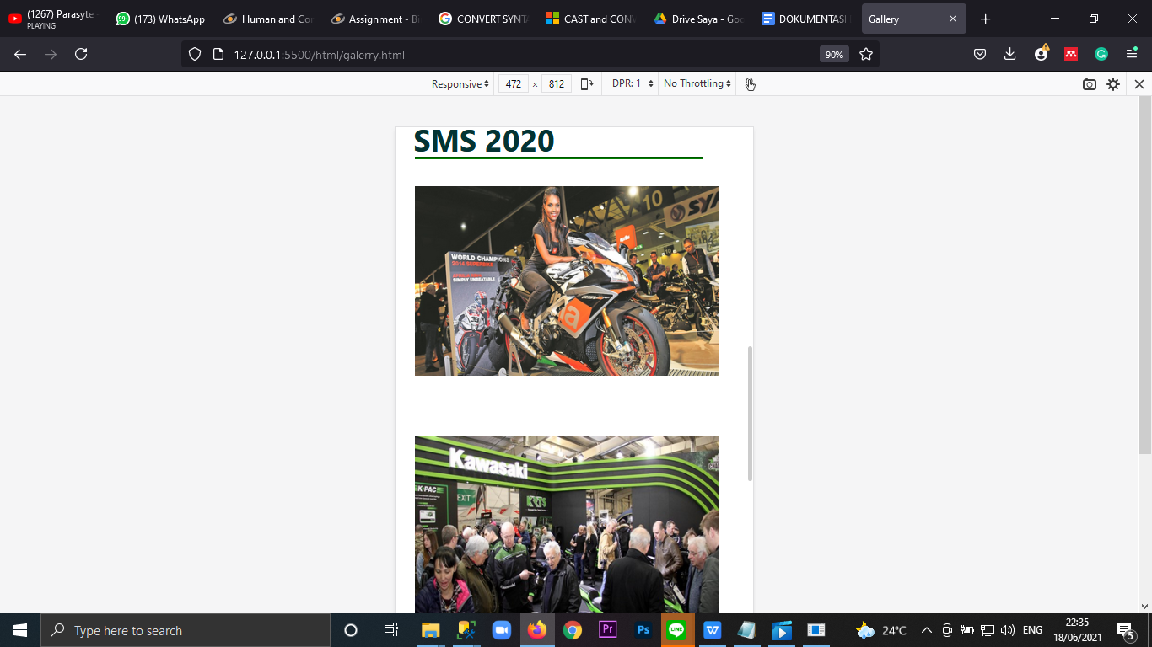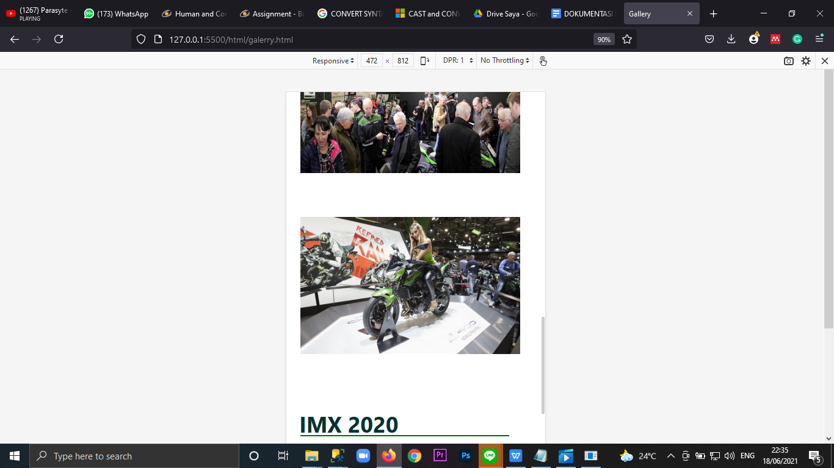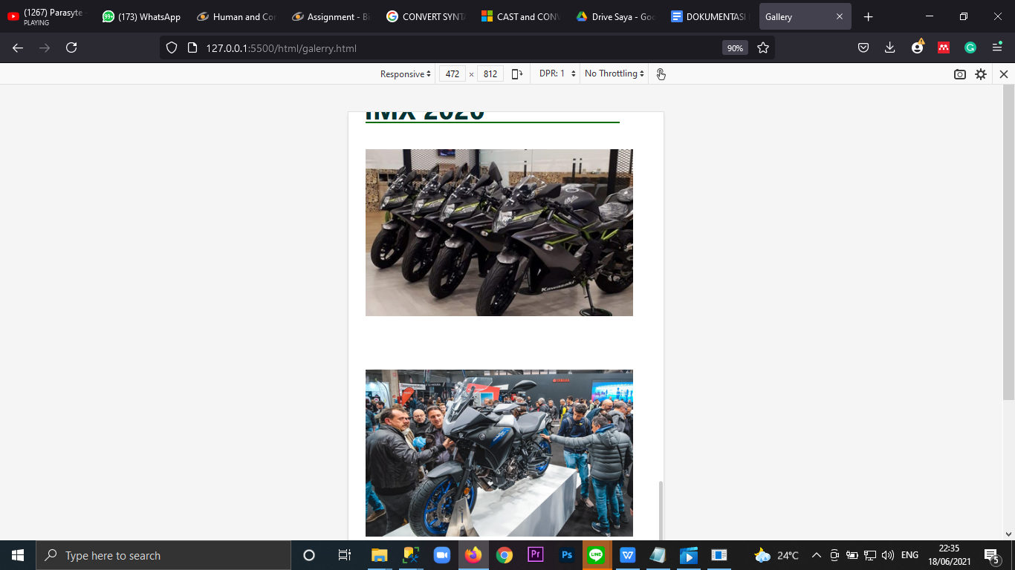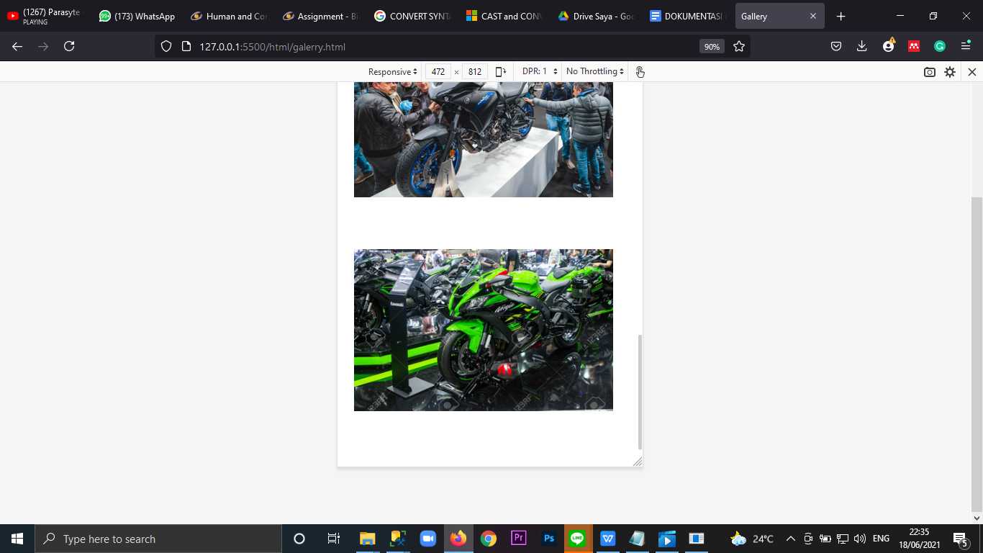

* **Reserve**

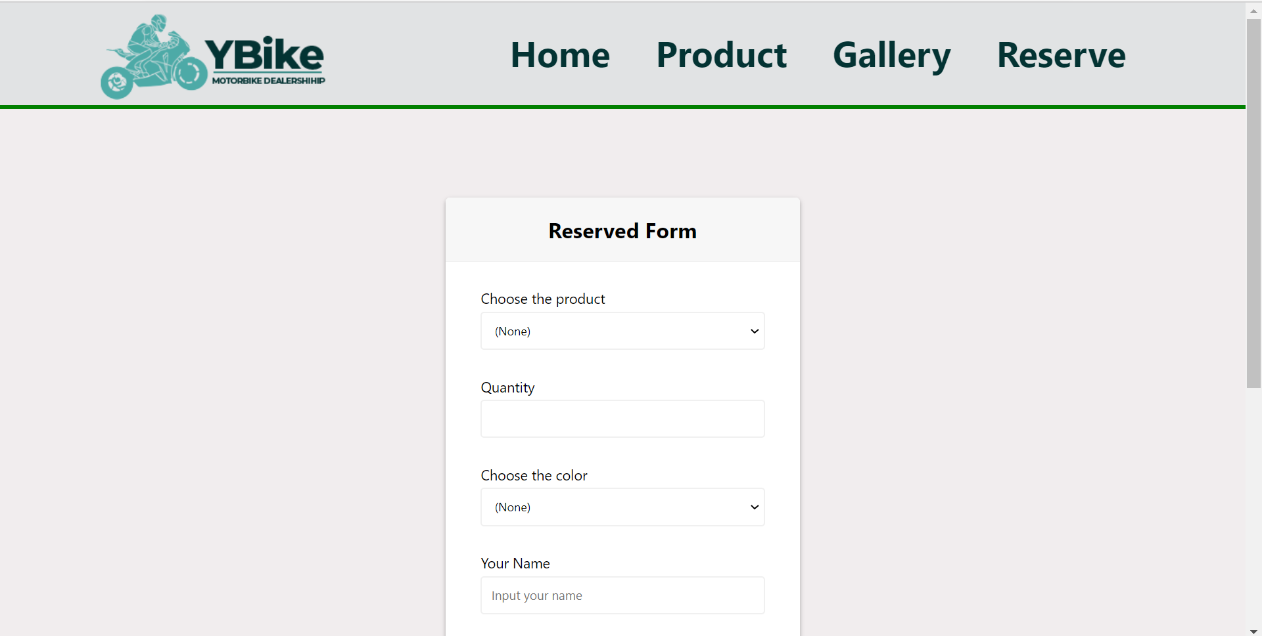

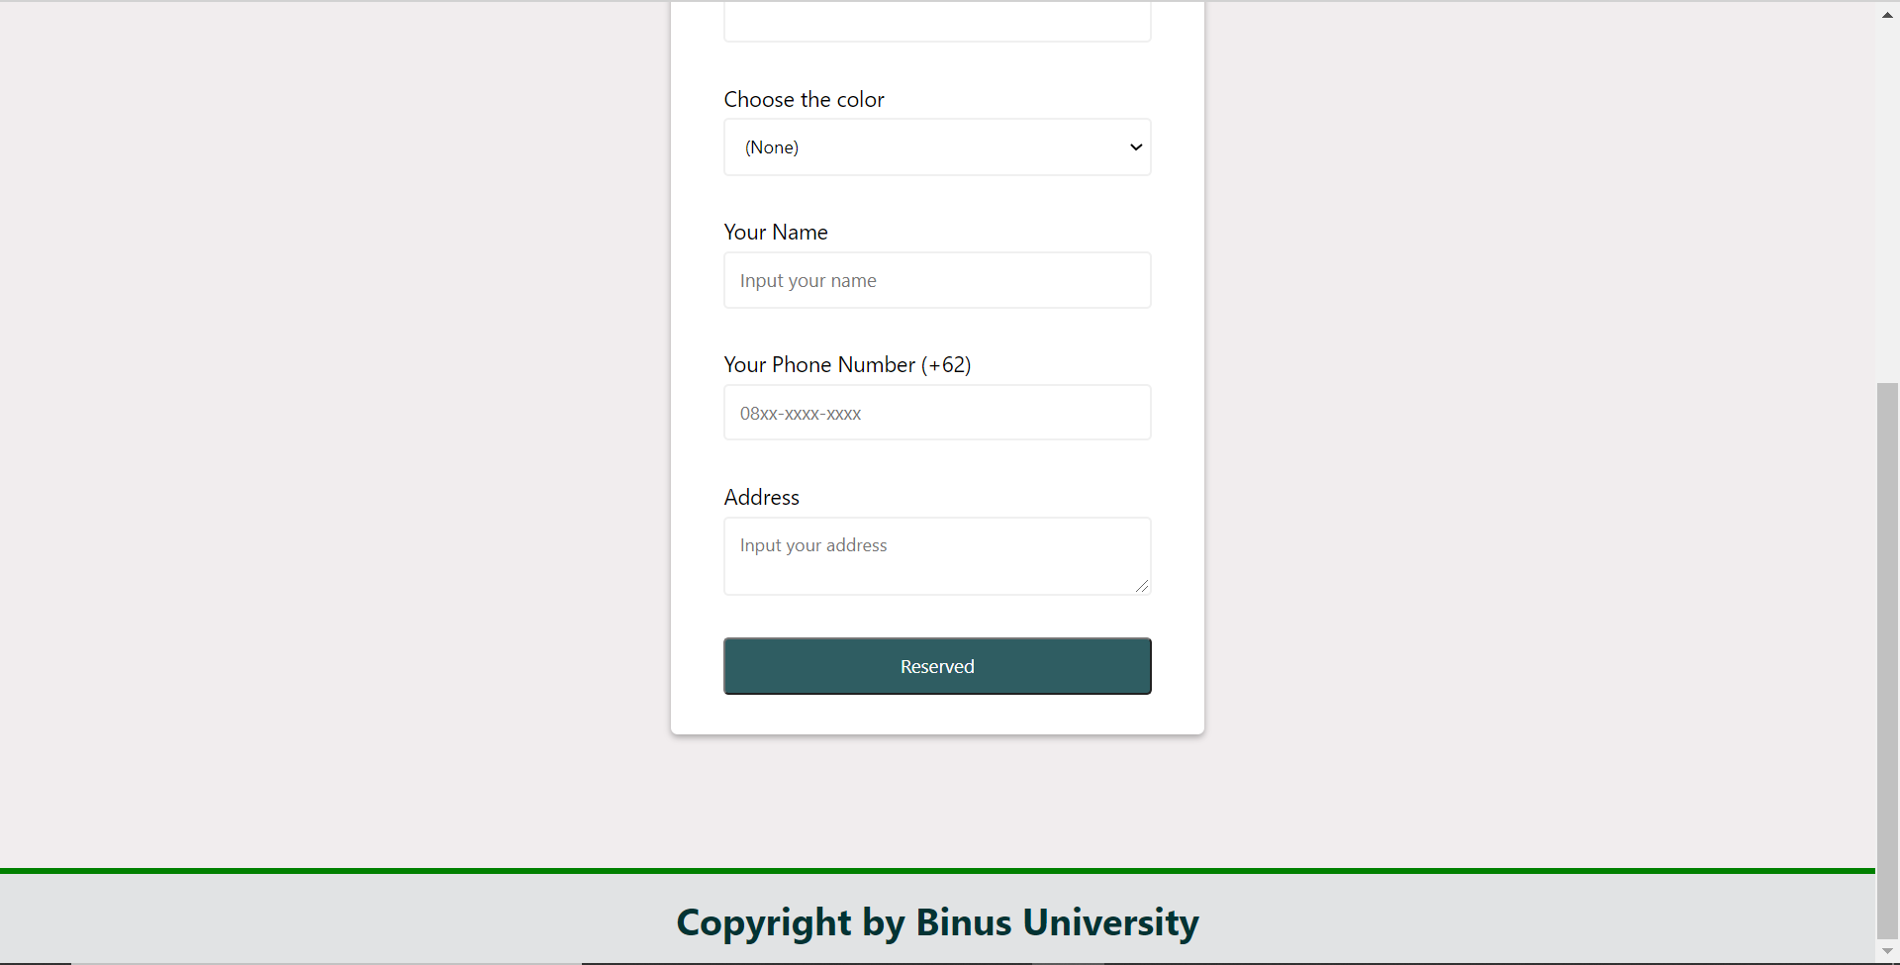

* **Tampilan Responsive pada reserve**

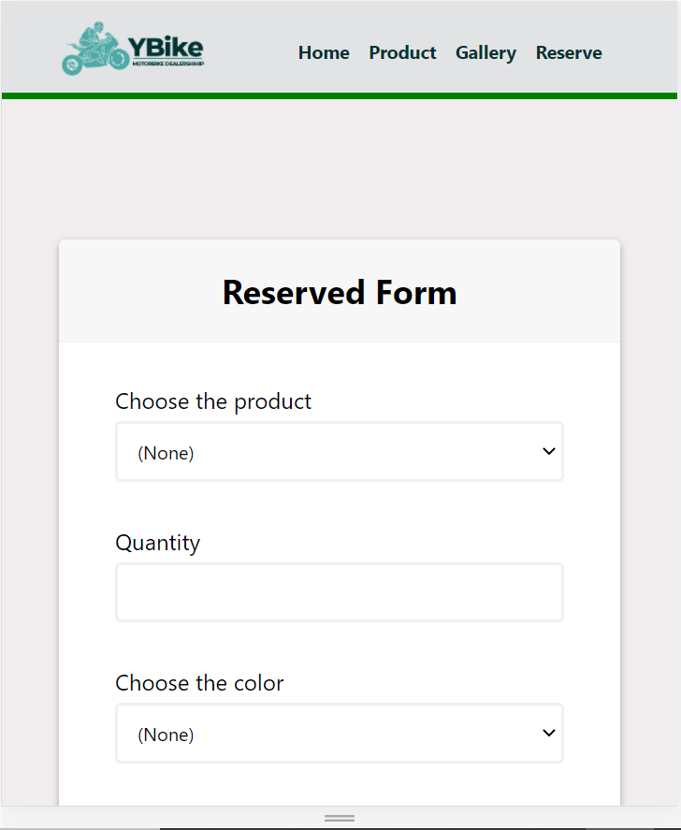

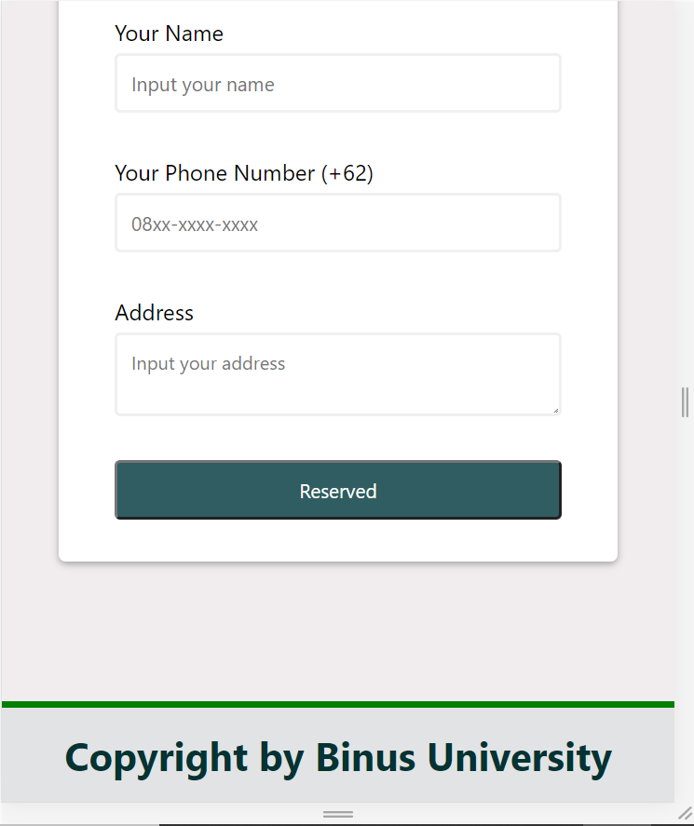

* **Validasi pada Reserved Form**

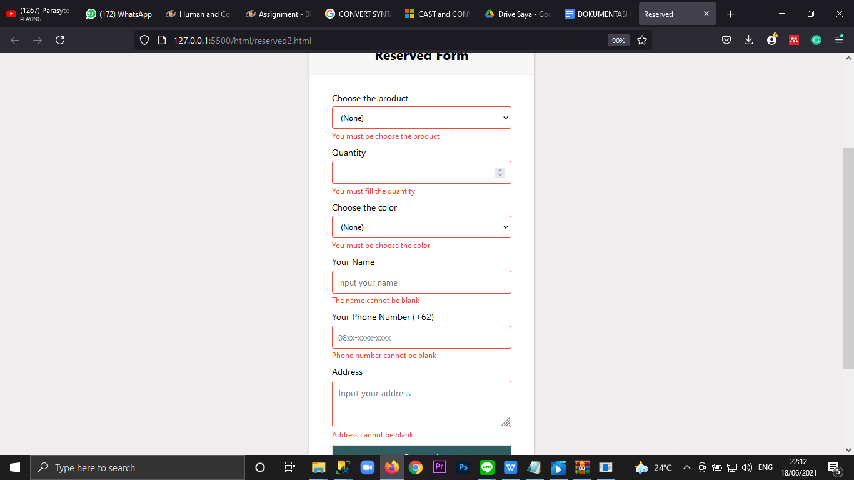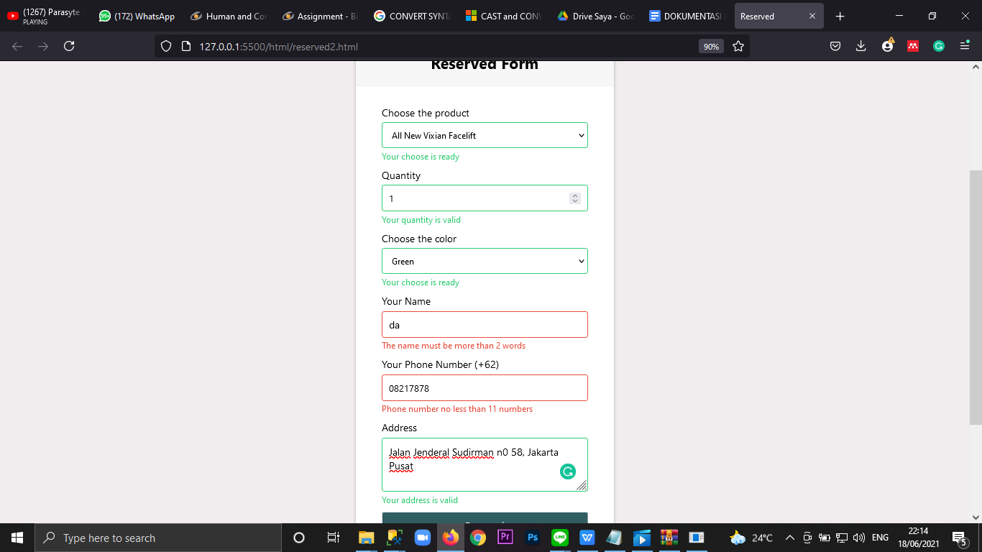

Disini kita membuat validasi dimana form tidak bisa menerima data yang kosong di semua formnya menggunakan JS (ditampilkan di gambar pertama), selain itu juga kita membuat validasi dimana jika data yang dimasukkan valid, akan ditampilkan seperti di gambar 2. Lalu kita juga membuat validasi di nama dimana nama tidak boleh kurang dari 2 huruf, jika kurang akan ditampilkan seperti di gambar 2. Kemudian di phone number juga kita melakukan 2 validasi, dimana phone number tidak bisa kurang dari 11 angka dan tidak boleh lebih dari 13 angka, jika terjadi maka akan ditampilkan seperti di gambar kedua.

Terakhir untuk select, kita membuat validasi dimana user harus memilih option yang ada, dimana option default ada di ‘none’, dimana itu tidak boleh (ada di gambar 1)

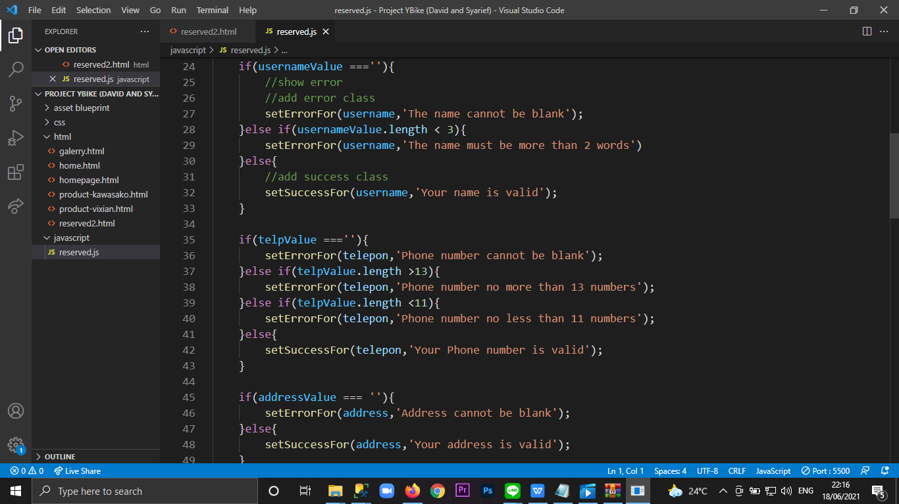

**(Kodingan di JavaScript)**

## 

## 

## 

## 

## **Referensi**

**REFERENCES**

Referensi aset

* https://www.blademotorcycles.co.uk/i/?item_id=123&item_type=banner&item_size=banner
* <https://media.istockphoto.com/photos/the-gray-and-silver-are-light-black-with-white-the-gradient-is-the-picture-id1188030698?k=6&m=1188030698&s=612x612&w=0&h=SgbYMmLtKh5z4hyP6MFgVcXCp_XFQ-HI8iHeixstfjw=>
* https://indonesiamotorcycleshow.id/wp-content/uploads/2021/02/banner-website-imos-rev2-01-01_rev.jpg
* <https://indonesiamodificationexpo.com/wp-content/uploads/2021/02/IMX-2021-Limitless-Logo.png>
* https://www.whatsonnetwork.co.uk/uploads/800x600/5e3cd60912af395068a08cdb60eb4d09.jpg
* https://imgcdnblog.carmudi.com.ph/motovaganza/wp-content/uploads/2016/02/15022016-Moto-Kawasaki-Ninja-H2H.jpg
* https://www.motoryamahasubang.com/wp-content/uploads/2018/03/yamaha-al-new-vixion-putih-hitam.jpg
* <https://th.bing.com/th/id/OIP.b2dLbd0aN5GvoYj3STEc9QHaFC?w=252&h=180&c=7&o=5&dpr=1.5&pid=1.7>
* https://awsimages.detik.net.id/community/media/visual/2018/11/01/73bf68b1-f88c-4f65-b3b4-3efa450c3dbf.jpeg?w=3190
* <https://content2.kawasaki.com/ContentStorage/KMI/Products/4527/3449d09b-b9a3-45bb-8ba6-71df1e0e288b.png?w=800&h=449>
* <https://www.kawasaki-motor.co.id/id-id/sepeda-motor/ninja/supersport/ninja-zx-25r/2021-ninja-zx-25r-abs-se>
* <https://amkrtqffen.cloudimg.io/cdn/n/n/https://www.wibloog.com/images/produk/images_konten_110424040_1563117130_44091200_1563117130.jpg>
* https://amkrtqffen.cloudimg.io/cdn/n/n/https://www.wibloog.com/images/produk/images_konten_7990514_1563118061_93244700_1563118061.jpg
* <https://encrypted-tbn0.gstatic.com/images?q=tbn:ANd9GcRHjtM9WN_ACU1XYBil5Hs3D14GXGEm12uVUA&usqp=CAU>
* <https://www.google.com/imgres?imgurl=https%3A%2F%2Frhc.dogdigital.net%2Fmedia%2F1261%2Fstand.jpg%3Fanchor%3Dcenter%26mode%3Dcrop%26width%3D1200%26height%3D630%26rnd%3D131255849340000000&imgrefurl=https%3A%2F%2Fwww.royalhighlandcentre.co.uk%2Fevents%2Fmcn-scottish-motorcycle-show%2F&tbnid=Swn8Y1rfNPnYTM&vet=12ahUKEwi5k4nLw6HxAhV6sksFHZh_CHMQMygCegUIARChAQ..i&docid=ebUw6MypXsPaNM&w=1200&h=630&q=scotish%20motorcycle%20show&safe=strict&client=firefox-b-d&ved=2ahUKEwi5k4nLw6HxAhV6sksFHZh_CHMQMygCegUIARChAQ>
* <https://www.google.com/imgres?imgurl=https%3A%2F%2Fwww.royalhighlandcentre.co.uk%2Fmedia%2F1903%2Fimg_4399.jpg%3Fanchor%3Dcenter%26mode%3Dcrop%26width%3D640%26height%3D320%26rnd%3D131884891620000000&imgrefurl=https%3A%2F%2Fwww.royalhighlandcentre.co.uk%2Fevents%2Fmcn-scottish-motorcycle-show%2F&tbnid=XfWEPrC2D1VnKM&vet=12ahUKEwi5k4nLw6HxAhV6sksFHZh_CHMQMygHegUIARCrAQ..i&docid=ebUw6MypXsPaNM&w=640&h=320&q=scotish%20motorcycle%20show&safe=strict&client=firefox-b-d&ved=2ahUKEwi5k4nLw6HxAhV6sksFHZh_CHMQMygHegUIARCrAQ>
* <https://www.google.com/imgres?imgurl=https%3A%2F%2Fwww.reviewsphere.org%2Fwp-content%2Fuploads%2F2019%2F02%2FMotorcycle-Show.jpg&imgrefurl=https%3A%2F%2Fwww.reviewsphere.org%2Fnews%2Fscotlands-biggest-and-best-motorcycle-show-is-back%2F&tbnid=x-7eSF4JM1J1_M&vet=12ahUKEwi5k4nLw6HxAhV6sksFHZh_CHMQMygMegUIARC1AQ..i&docid=dLDLoHSFF9PdRM&w=604&h=340&itg=1&q=scotish%20motorcycle%20show&safe=strict&client=firefox-b-d&ved=2ahUKEwi5k4nLw6HxAhV6sksFHZh_CHMQMygMegUIARC1AQ>
* <https://encrypted-tbn0.gstatic.com/images?q=tbn:ANd9GcTWSqVTT6-7ZACBVMFwDmZEWjZJ0zq5GuaJ4Q&usqp=CAU>

Disiapkan Oleh,

*Prepared by,*

**2301932456 - 1st David YU**

**2301899250 – 2nd Syarief Kamal**